**IMPLEMENTING CALCULATION VIEW OF TYPE DIMENSION WITH CUSTOMER**

**Calculation Views:**

* Calculation Views are used to consume Analytic, Attribute and other Calculation Views.
* They are used to perform complex calculations, which are not possible with other Views.
* There are two ways to create Calculation Views- SQL Editor or Graphical Editor.
* Built-in Union, Join, Projection & Aggregation nodes.

**If the data category is set to dimension:**

The output node does not offer any measures (or hierarchies), only attributes, which can be numerical data types

The calculation view is not available for reporting.

The calculation view is only consumable via SQL.

The default node is projection.

How to create calculation view of type dimension with customer data:

Go to remote desktop connection<start<click on saphana studio

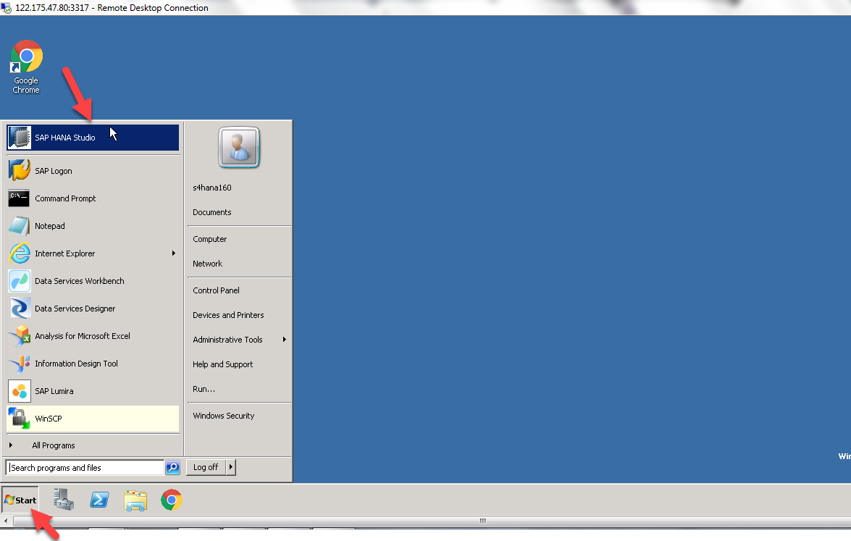

Right click on sub package<new<click on calculation view

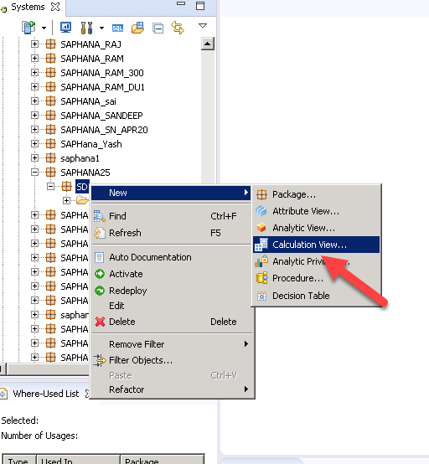

Provide name<provide label<select data category as dimension<click finish

In calculation view we have two sub types

1. Standard
2. Time

Here we can choose subtype as standard

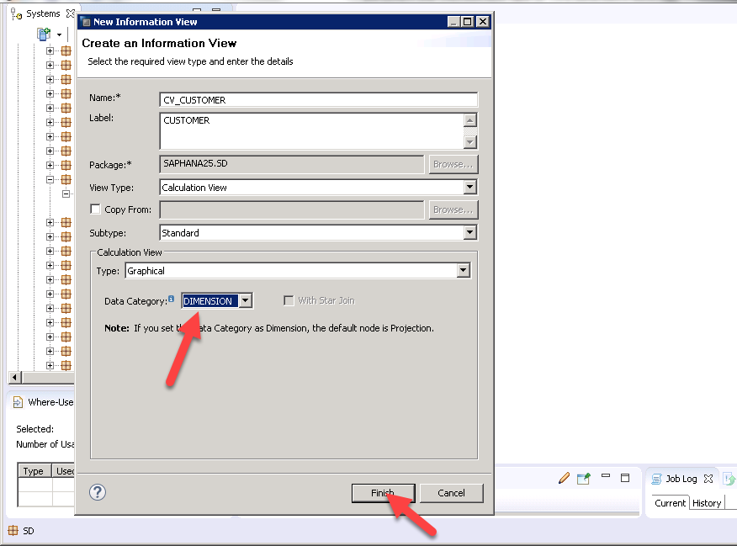

In calculation view of type dimension the default node is projection

**Projection:** This is used to fine tune our source objects before we use in next nodes like union, aggregation and rank.

We can choose the selective columns, filter the data and create additional columns.

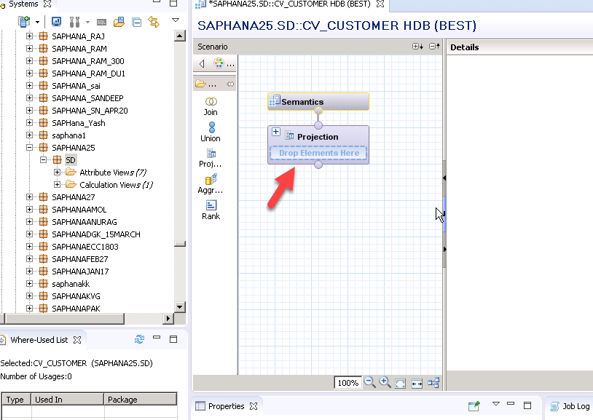

Click on join<drag and drop the work area

Join: it is a simple join it accepts two tables only

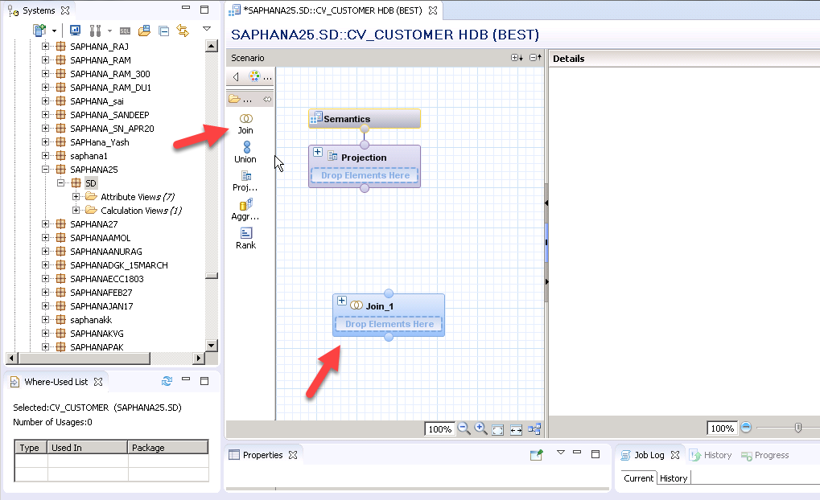

Click on plus icon<select a KNA1 table<click ok

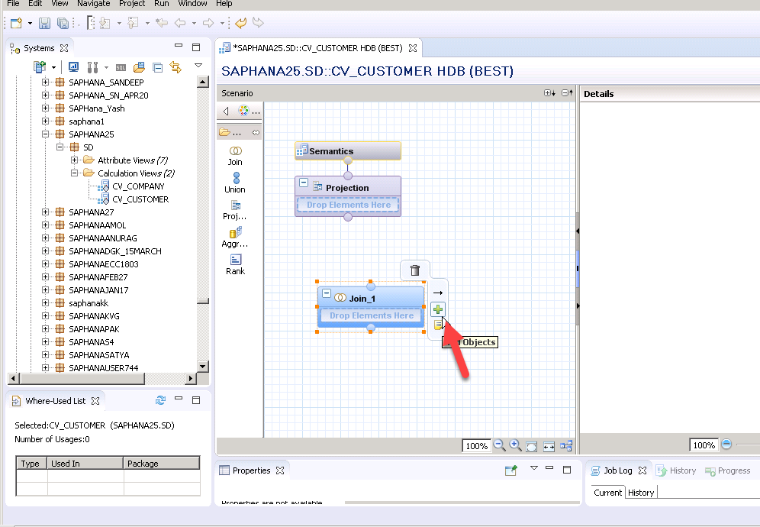

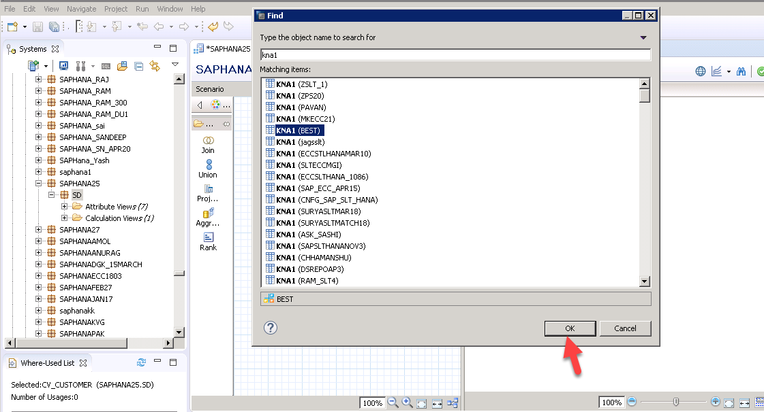

Again click on plus icon<select T005T table<click ok

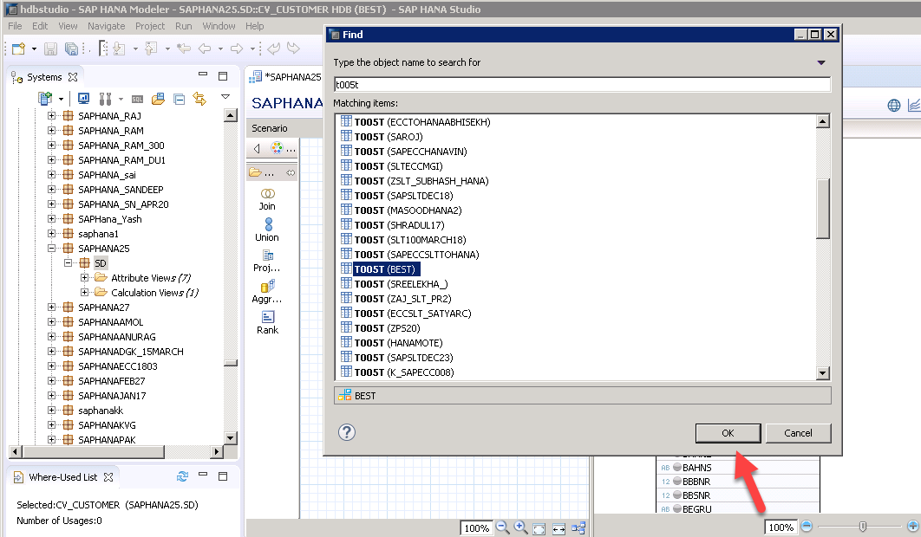

Join KNA1 LAND1 to T005T LAND1<select join type as text join<language column as SPRAS

Text join: text join is used to fetch the description based on user's session language. Once we implement the text join in sap hana, it automatically finds out user's language and gives description in that language

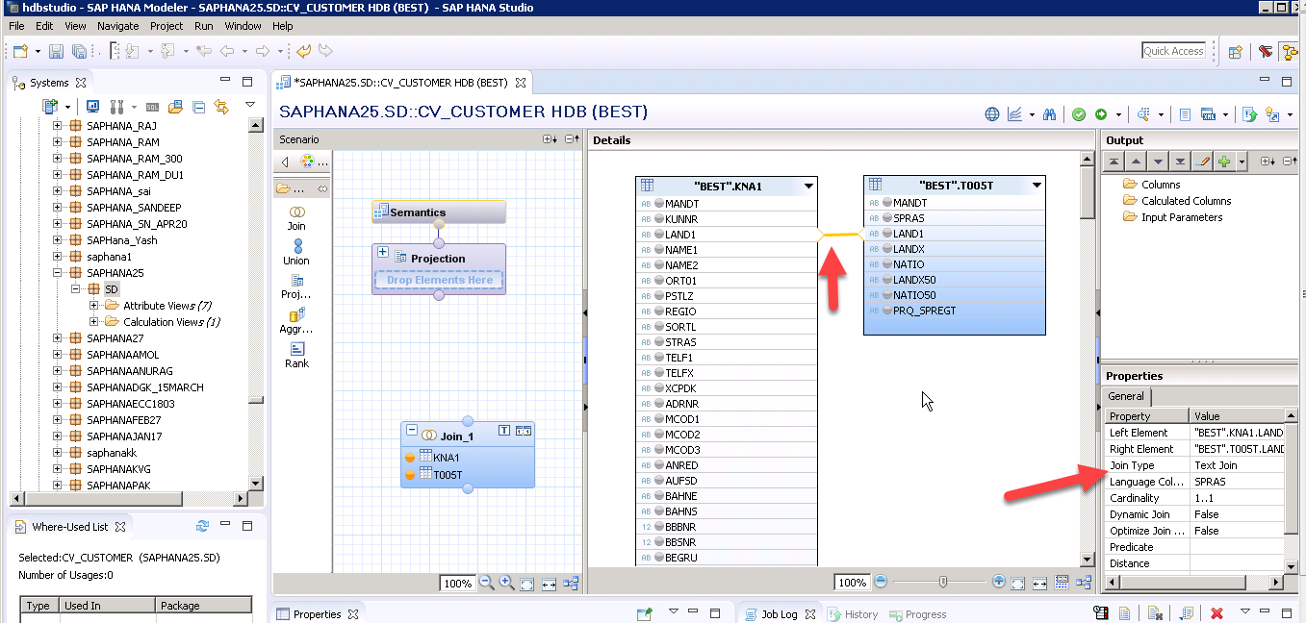

Select required output columns

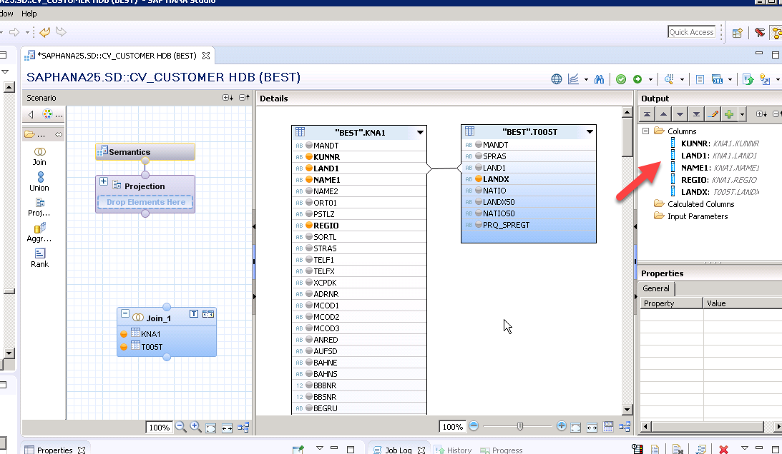

Again click on join<drag and drop work area

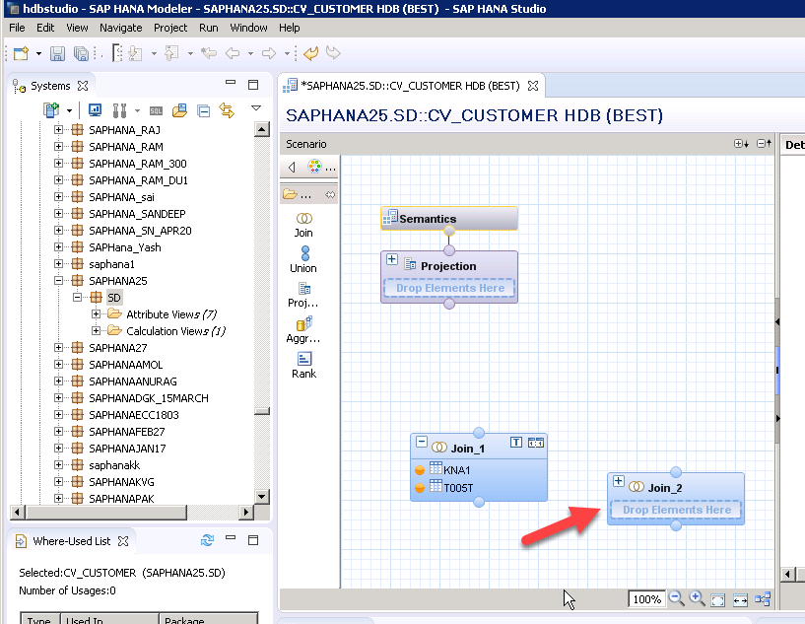

Connect the join1 to join2

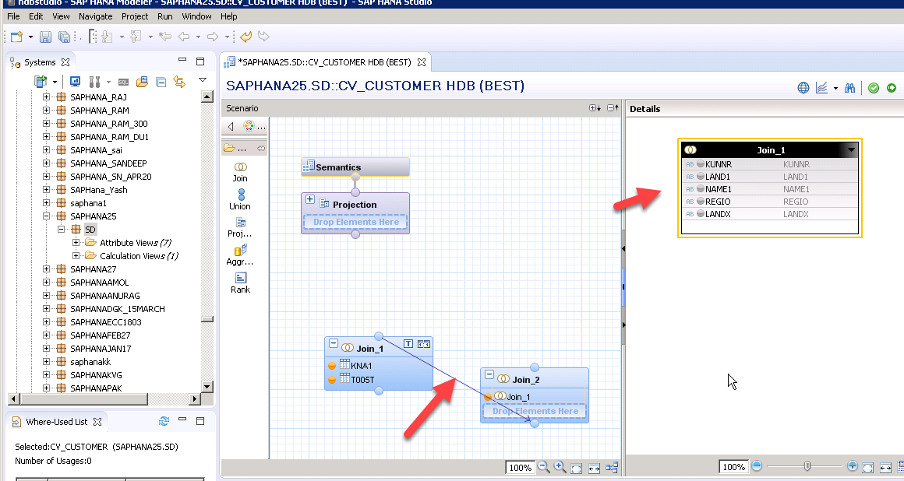

Click on join2 plus icon<select T005U table<click ok

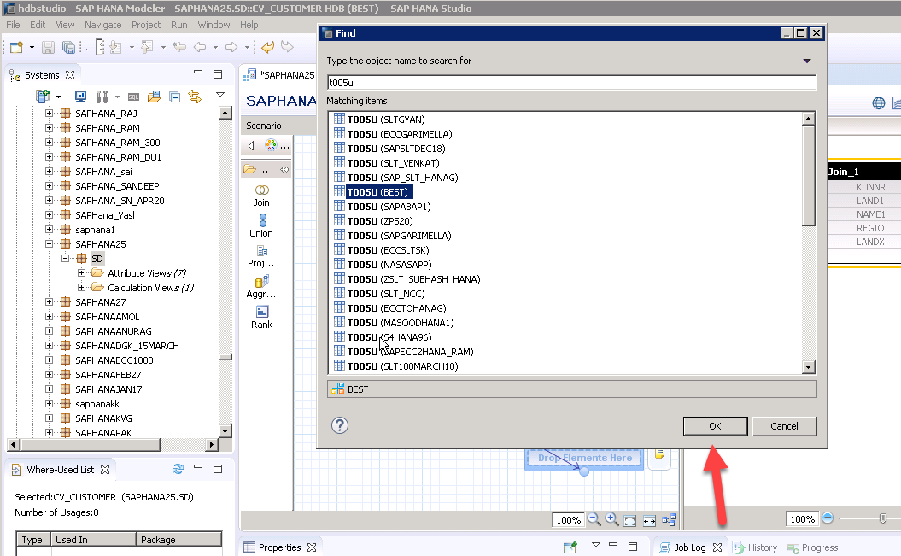

Connect the join1 LAND1 to T005U LAND1<join type as text join<language column as SPRAS

Connect the join1 REGIO to T005U BLAND<join type as text join<language column as SPRAS

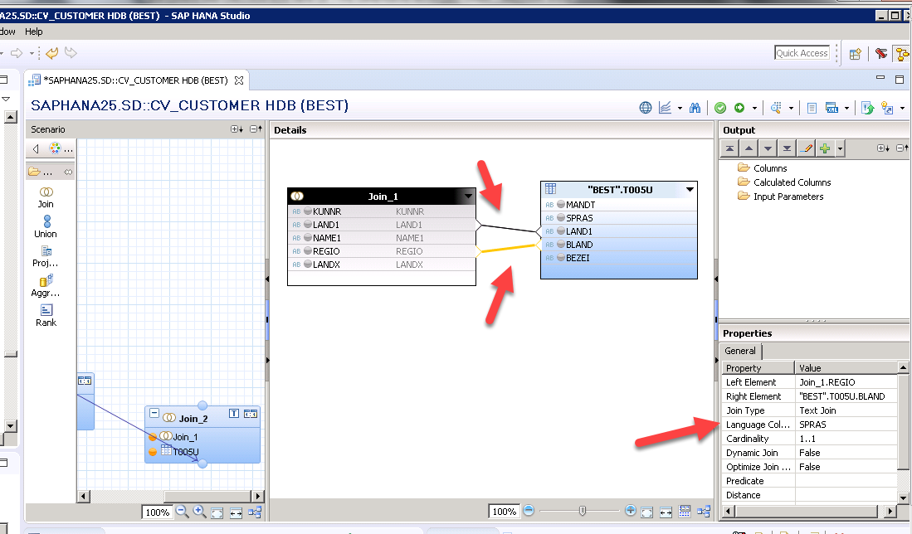

Select the required output columns

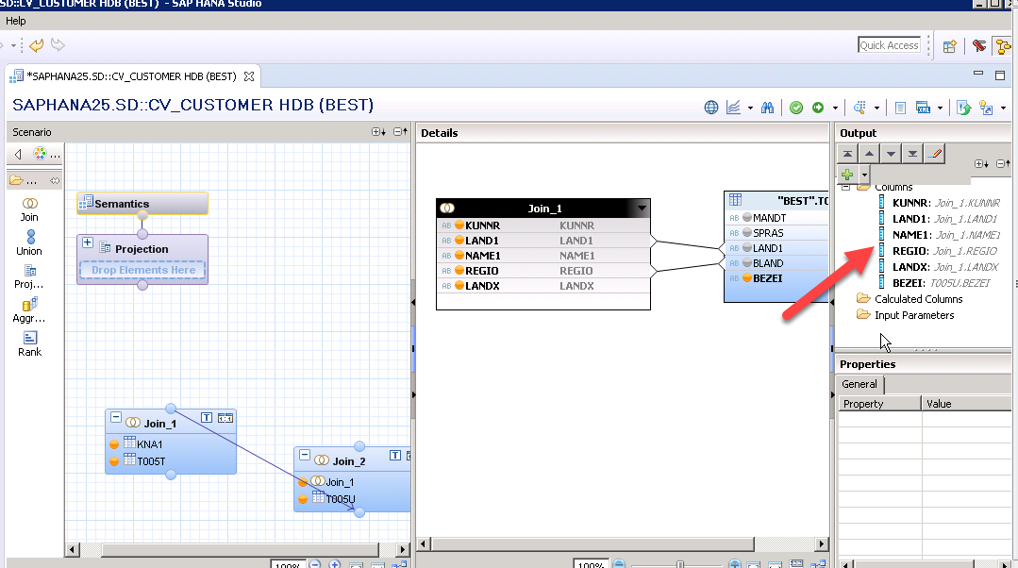

Connect the join2 to projection

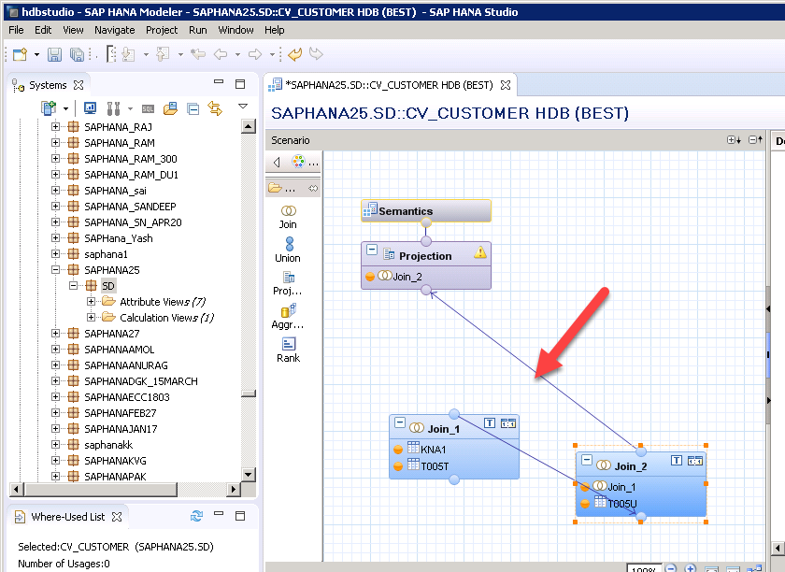

Click on projection<select required output columns

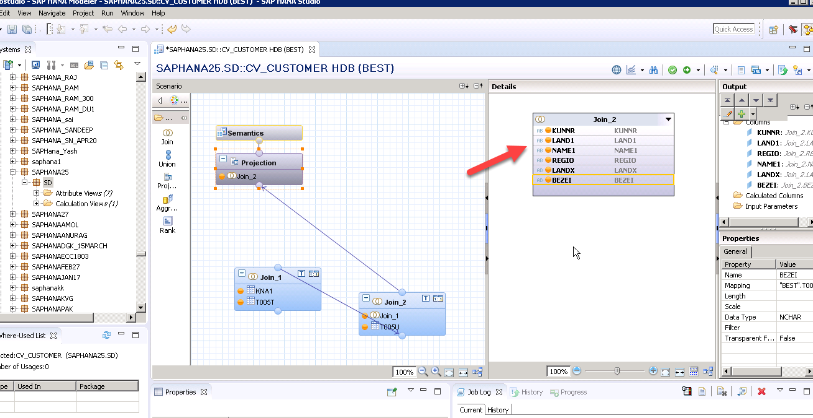

Click on semantics<select key attribute<provide label mapping

**Label mapping:**

We can choose to associate an attribute with another attribute description. Label

Mapping is also called as description mapping. For example if a1 has a label column

B1, then you can rename b1 to a1.description. The related columns appear side by

Side during data preview

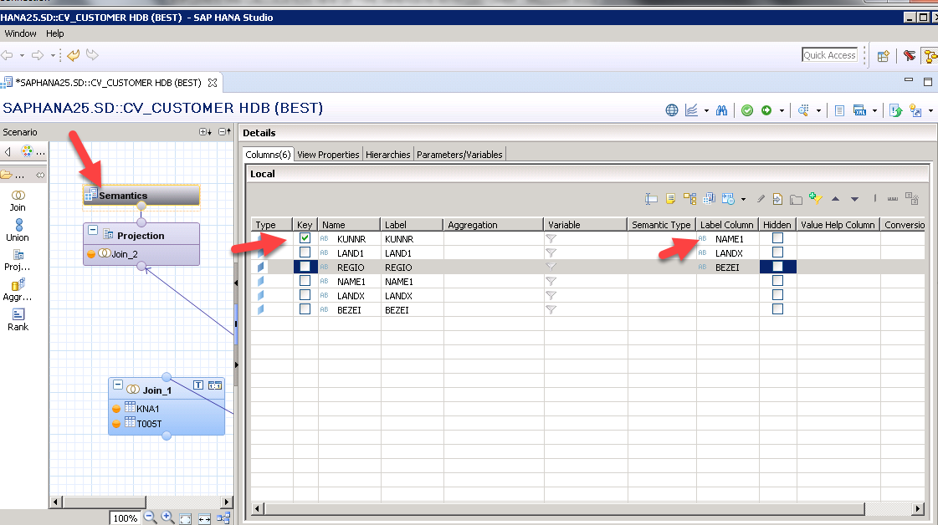

Click on projection<click on work area<properties<calculation view by default execute in CE engine <now we can select<execute in as sql engine

Sql engine: compared to other engines it has better join determination technique

View executes fast

If we are not select also nothing will happened but we cannot take the advantage of sql engine

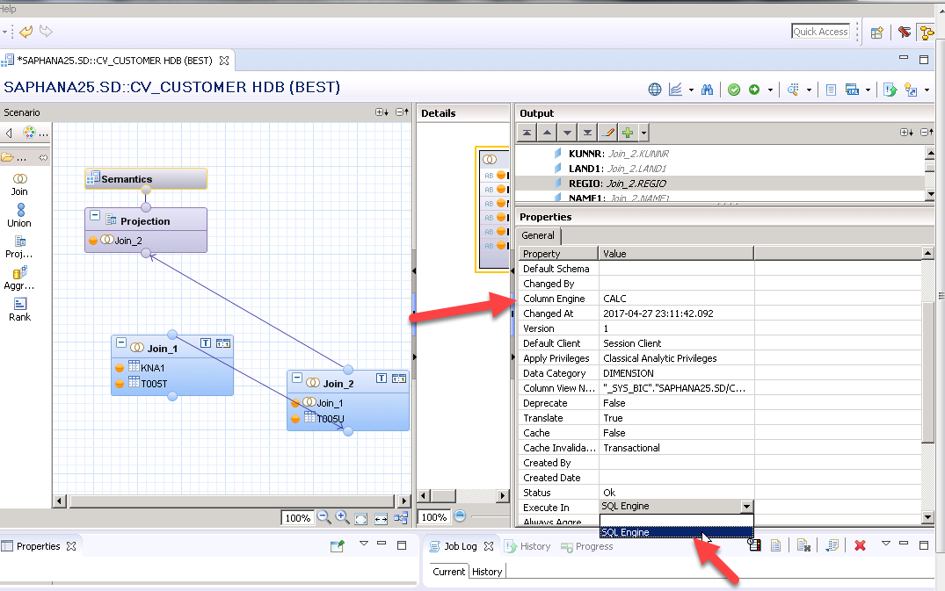

Click on Save and validate <click on save and activate

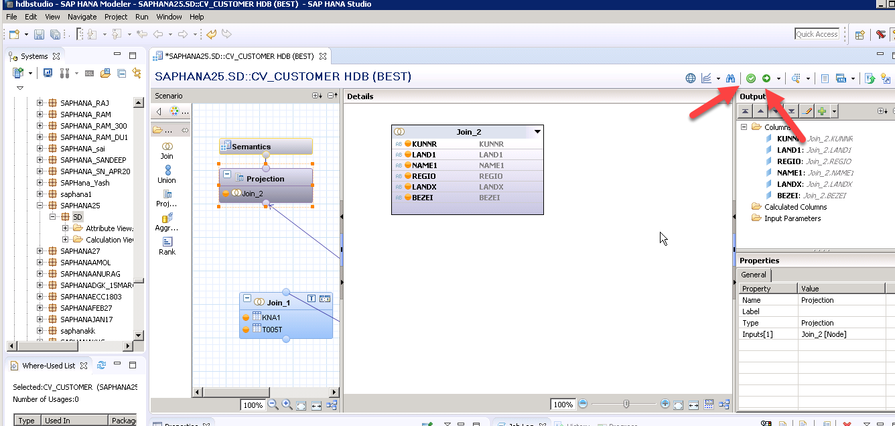

Assign a object<click finish

**Use of assign object**: in the select change dialog, either create a new id or select an existing change id that you want to use to assign your change

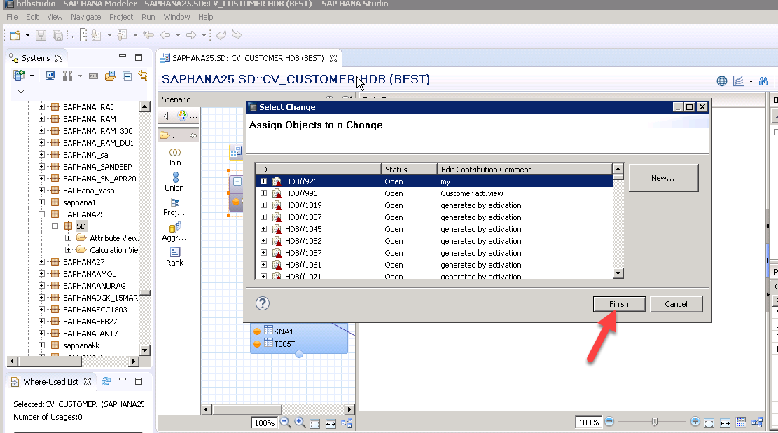

Click on data preview

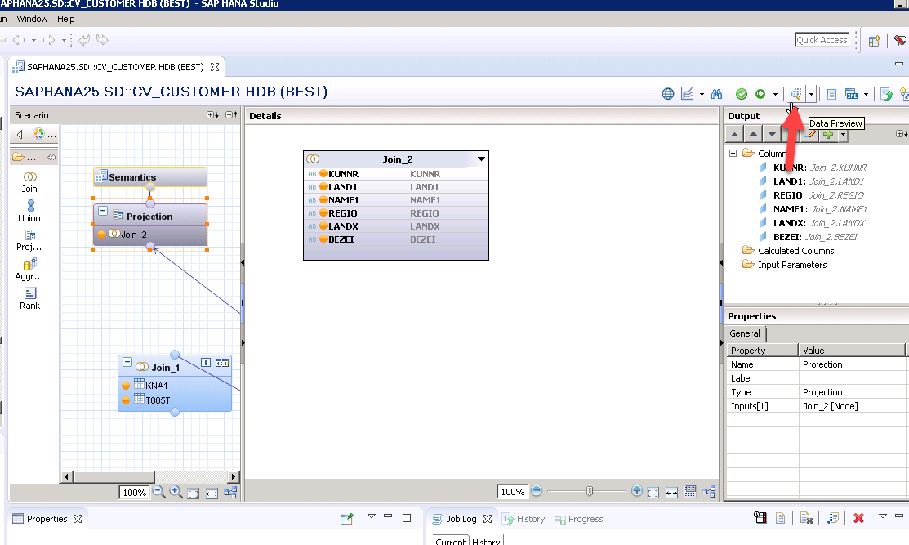

Click on raw data

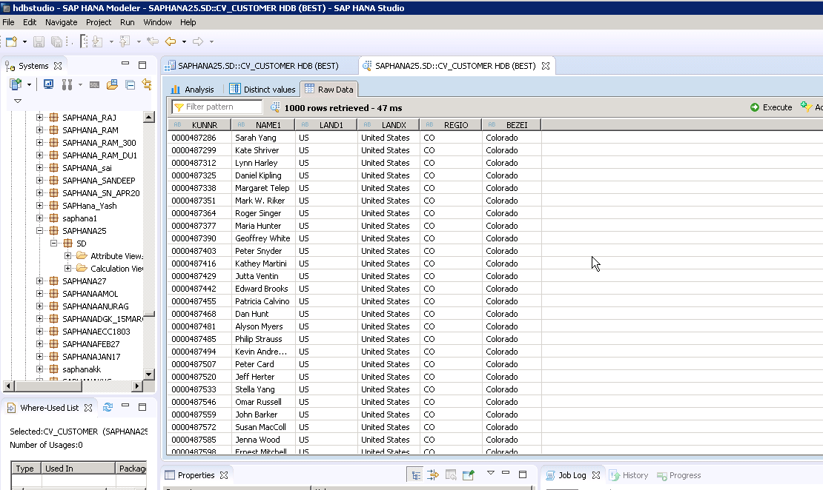

Output in different language:

Go to best system<right click on system<click on properties

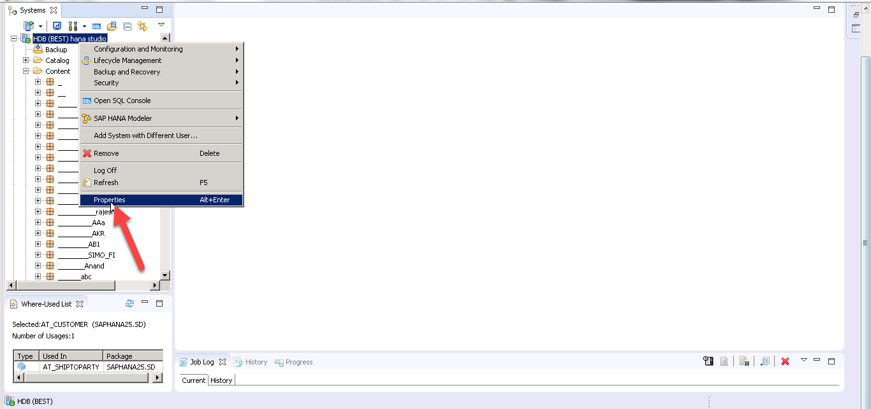

Click additional properties<select locale<click apply<click ok

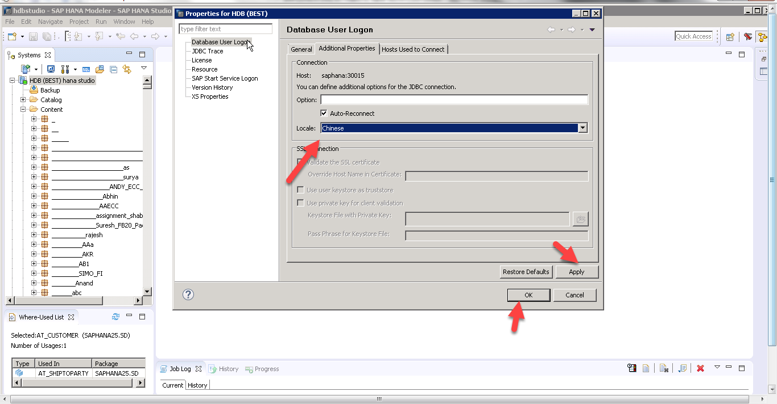

Click save and validate<click save and activate<click on data preview<click on raw data

